1. Create VPC.
2. Create an Internet gateway.
3. Create Custom Route Table.
4. Create a Subnet.
5. Associate subnet with Route Table.
6. Create a Security Group to allow port 22.80,443.
7. Create a network interface with an ip in the subnet that was created in step 4.
8. Assign an elastic IP to the network interface created in step 7.
9. Create Ubuntu server and install/enable apache2.

Infrastructure Documentation: AWS Custom VPC & Apache Web Server on Terraform

1. Project Overview
- Project Name: Custom VPC with EC2, Elastic IP, and Apache Web Server
- Cloud Provider: AWS
- Region: Mumbai (ap-south-1)
- Provisioning Tool: Terraform
- Architecture: Isolated Virtual Private Cloud (VPC) featuring a custom Subnet, Internet Gateway, Custom Route Table, Security Group, Elastic Network Interface (ENI), Elastic IP (EIP), and an Ubuntu EC2 instance running Apache2.

2. Architecture & Step-by-Step Implementation Summary

Step 1: Virtual Private Cloud (VPC)
- Resource: aws_vpc.main
- CIDR Block: 10.0.0.0/16
- Purpose: Creates an isolated private network container allowing up to 65,536 private IP addresses. Enables DNS hostnames and support.

Step 2: Internet Gateway
- Resource: aws_internet_gateway.gw
- Purpose: Acts as the bridge between your private VPC and the public internet, allowing inbound and outbound web traffic.

Step 3 & 5: Custom Route Table & Subnet Association
- Resources: aws_route_table.custom_rt, aws_subnet.subnet_1, aws_route_table_association.a
- Subnet CIDR: 10.0.1.0/24 (Availability Zone: ap-south-1a)
- Purpose: Segments a portion of the VPC network (10.0.1.0/24) and associates a custom route directing all outbound internet traffic (0.0.0.0/0) through the Internet Gateway.

Step 6: Security Group
- Resource: aws_security_group.allow_web_ssh
- Purpose: Acts as a virtual firewall governing inbound and outbound packet permissions.
- Inbound Rules Allowed:
  - Port 22 (SSH): Remote management access.
  - Port 80 (HTTP): Public web traffic.
  - Port 443 (HTTPS): Secure web traffic.

- Outbound Rules: Allows all outbound traffic (-1).

Step 7: Elastic Network Interface (ENI)
- Resource: aws_network_interface.nic
- Assigned Private IP: 10.0.1.50
- Purpose: Creates a standalone virtual network card pinned inside your subnet with a static private IP and security group bindings.

Step 8: Elastic IP (EIP)
- Resource: aws_eip.one
- Purpose: Allocates a permanent, static public IP address from AWS and binds it directly to the custom network interface (10.0.1.50) to ensure reliable public access.

Step 9: Ubuntu EC2 Instance & Apache Setup
- Resource: aws_instance.web_server
- Instance Type: t3.micro
- AMI Source: Dynamically fetched Canonical Ubuntu 24.04 LTS Data Source for ap-south-1.
- Purpose: Boots up the server compute hardware, links the custom network interface (eni), and runs an automated user_data bash script on first boot to install, start, and enable Apache2, while writing a custom index page.

3. Terraform Configuration File (main.tf)
Terraform
provider "aws" {
region = "ap-south-1"
}

# 1. Create VPC
resource "aws_vpc" "main" {
cidr_block = "10.0.0.0/16"
enable_dns_hostnames = true
enable_dns_support = true

tags = {
Name = "custom-vpc"
}
}

# 2. Create an Internet Gateway
resource "aws_internet_gateway" "gw" {
vpc_id = aws_vpc.main.id

tags = {
Name = "custom-igw"
}
}

# 3. Create Custom Route Table
resource "aws_route_table" "custom_rt" {
vpc_id = aws_vpc.main.id

route {
cidr_block = "0.0.0.0/0"
gateway_id = aws_internet_gateway.gw.id
}

tags = {
Name = "custom-route-table"
}
}

# 4. Create a Subnet
resource "aws_subnet" "subnet_1" {
vpc_id = aws_vpc.main.id
cidr_block = "10.0.1.0/24"
availability_zone = "ap-south-1a"

tags = {
Name = "custom-subnet"
}
}

# 5. Associate Subnet with Route Table
resource "aws_route_table_association" "a" {
subnet_id = aws_subnet.subnet_1.id
route_table_id = aws_route_table.custom_rt.id
}

# 6. Create Security Group to allow ports 22, 80, 443
resource "aws_security_group" "allow_web_ssh" {
name = "allow_web_ssh"
description = "Allow TLS, HTTP and SSH inbound traffic"
vpc_id = aws_vpc.main.id

ingress {
description = "HTTPS"
from_port = 443
to_port = 443
protocol = "tcp"
cidr_blocks = ["0.0.0.0/0"]
}

ingress {
description = "HTTP"
from_port = 80
to_port = 80
protocol = "tcp"
cidr_blocks = ["0.0.0.0/0"]
}

ingress {
description = "SSH"
from_port = 22
to_port = 22
protocol = "tcp"
cidr_blocks = ["0.0.0.0/0"]
}

egress {
from_port = 0
to_port = 0
protocol = "-1"
cidr_blocks = ["0.0.0.0/0"]
}

tags = {
Name = "allow_web_ssh"
}
}

# 7. Create Network Interface with an IP in the Subnet
resource "aws_network_interface" "nic" {
subnet_id = aws_subnet.subnet_1.id
private_ips = ["10.0.1.50"]
security_groups = [aws_security_group.allow_web_ssh.id]

tags = {
Name = "custom-nic"
}
}

# 8. Assign an Elastic IP to the Network Interface
resource "aws_eip" "one" {
domain = "vpc"
network_interface = aws_network_interface.nic.id
associate_with_private_ip = "10.0.1.50"
depends_on = [aws_internet_gateway.gw]
}

# Dynamically fetch the latest official Ubuntu 24.04 LTS AMI for ap-south-1
data "aws_ami" "ubuntu" {
most_recent = true

filter {
name = "name"
values = ["ubuntu/images/hvm-ssd-gp3/ubuntu-noble-24.04-amd64-server-*"]
}

filter {
name = "virtualization-type"
values = ["hvm"]
}

owners = ["099720109477"] # Canonical
}

# 9. Create Ubuntu Server and install/enable Apache2
resource "aws_instance" "web_server" {
ami = data.aws_ami.ubuntu.id
instance_type = "t3.micro"
availability_zone = "ap-south-1a"

primary_network_interface_id = aws_network_interface.nic.id

user_data = <<-EOF
#!/bin/bash
apt-get update -y
apt-get install apache2 -y
systemctl start apache2
systemctl enable apache2
echo "Hello from Terraform Ubuntu Server" > /var/www/html/index.html
EOF

tags = {
Name = "ubuntu-apache-server"
}
}

4. Useful Commands for Management
- Validate Configuration: terraform validate
- Preview Changes: terraform plan
- Deploy Infrastructure: terraform apply
- Tear Down Infrastructure: terraform destroy

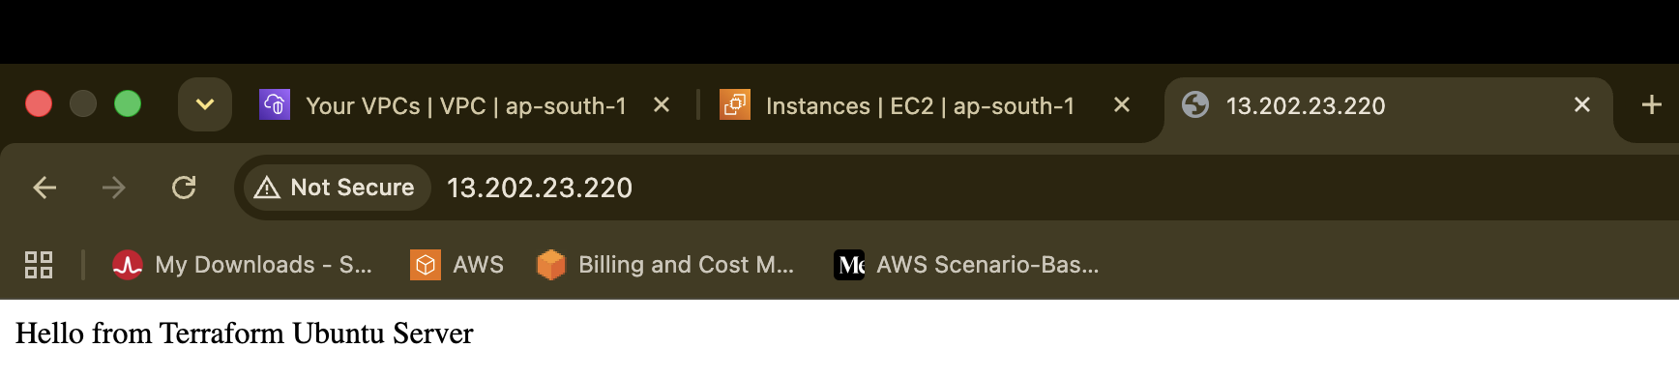
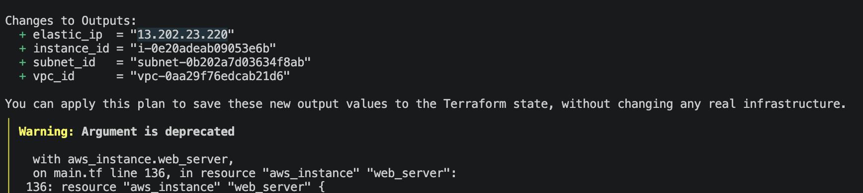

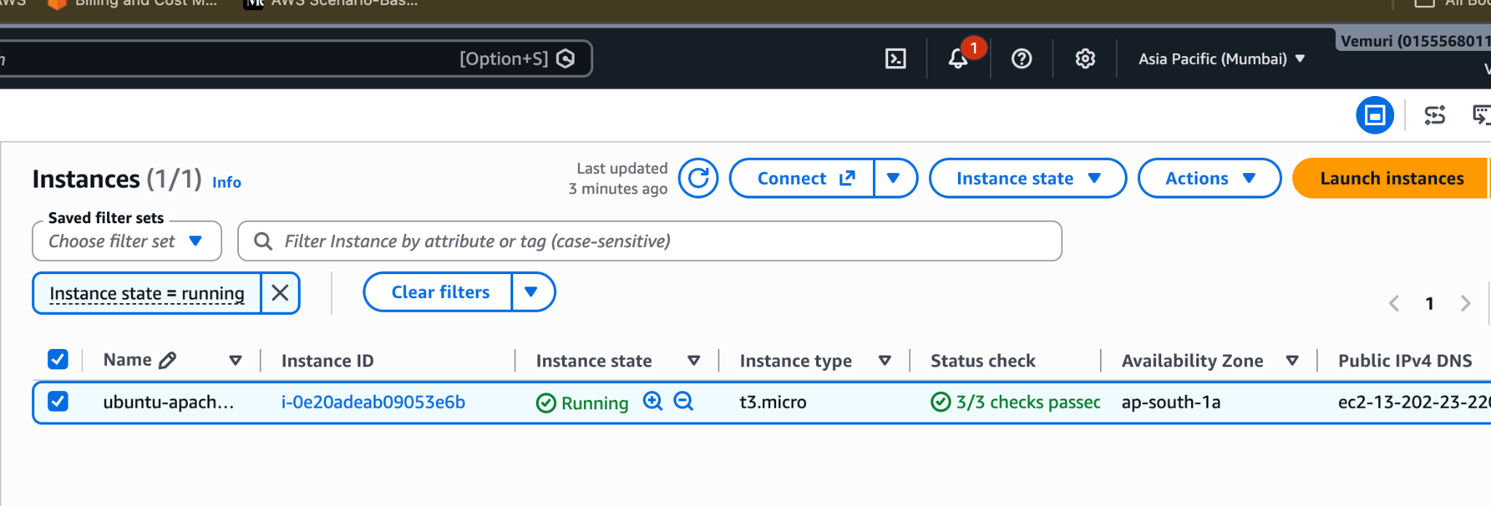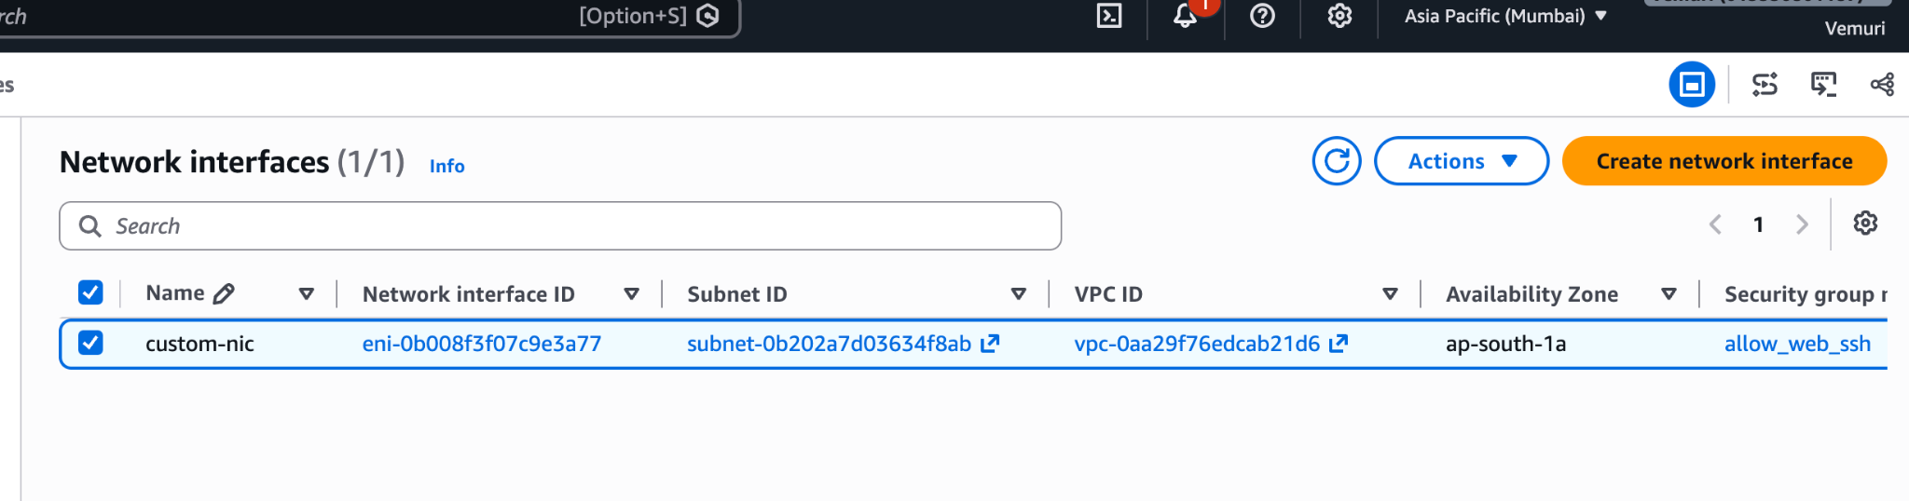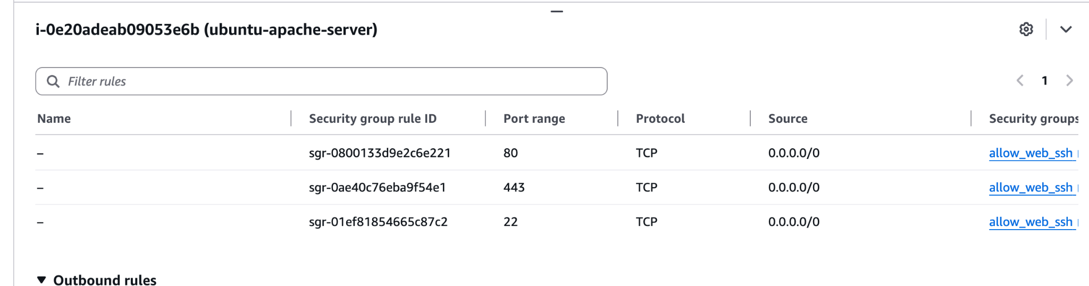

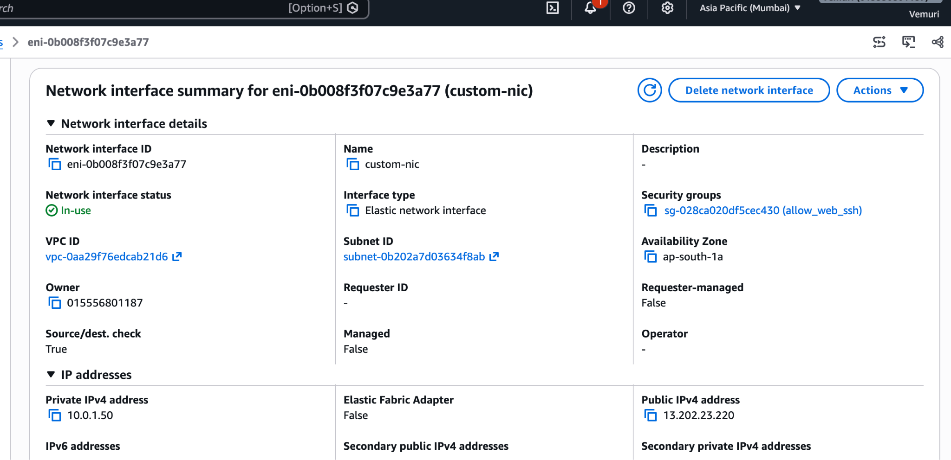

Terraform Infrastructure Code Breakdown & Reference Guide
This comprehensive reference document breaks down every section of your Terraform configuration for future reference, explaining the purpose of each resource, how they are interlinked, where the parameters originate, and how the network flows.

1. Provider Configuration
Terraform
provider "aws" {
region = "ap-south-1"
}

- Aim: Establish a secure and authorized connection to your target cloud provider.
- Objective: Tell Terraform which cloud (AWS) and which data center region (ap-south-1 / Mumbai) to deploy all resources into.
- How it works: Terraform downloads and initializes the official HashiCorp AWS provider plugin. Every resource created after this block will automatically inherit this region unless overridden.

2. Step 1: Virtual Private Cloud (VPC)
Terraform
resource "aws_vpc" "main" {
cidr_block = "10.0.0.0/16"
enable_dns_hostnames = true
enable_dns_support = true

tags = {
Name = "custom-vpc"
}}

- Aim: Establish an isolated virtual network environment in the cloud.
- Objective: Create a private IP address boundary (10.0.0.0/16) to safely host your servers and databases.

- Line-by-Line Breakdown:

  - resource "aws_vpc" "main": Tells Terraform to provision an AWS VPC resource named main.
  - cidr_block = "10.0.0.0/16": Allocates 65,536 private IP addresses (10.0.0.0 to 10.0.255.255) to this virtual network.
  - enable_dns_hostnames = true: Permits instances inside this VPC to receive public DNS hostnames.
  - enable_dns_support = true: Turns on the internal AWS DNS resolver.
  - tags: Labels the resource as custom-vpc in the AWS console for easy identification.

- IP Source & Interlinking: The VPC acts as the parent IP pool. All subsequent subnets draw their smaller address blocks from this 10.0.0.0/16 range.

3. Step 2: Internet Gateway (IGW)
Terraform
resource "aws_internet_gateway" "gw" {
vpc_id = aws_vpc.main.id

tags = {
Name = "custom-igw"
}
}

- Aim: Connect your isolated private VPC to the public internet.
- Objective: Enable bidirectional traffic flow between internal resources and the outside world.

- Line-by-Line Breakdown:
  - resource "aws_internet_gateway" "gw": Creates an Internet Gateway named gw.
  - vpc_id = aws_vpc.main.id: Dynamically fetches the unique ID of the VPC created in Step 1, locking this gateway to your VPC.

- IP Source & Interlinking: It does not consume an IP address from your subnet pool; instead, it acts as the translation bridge between your internal private IPs and public IPv4 addresses. It links directly using aws_vpc.main.id.

4. Step 3: Custom Route Table
Terraform
resource "aws_route_table" "custom_rt" {
vpc_id = aws_vpc.main.id

route {
cidr_block = "0.0.0.0/0"
gateway_id = aws_internet_gateway.gw.id
}

tags = {
Name = "custom-route-table"
}
}

- Aim: Direct network traffic coming in and out of the VPC.

- Objective: Define explicit routing rules instructing network packets where to travel.

- Line-by-Line Breakdown:

  - vpc_id = aws_vpc.main.id: Associates this route table with your VPC.
  - route { ... }: Defines a rule stating that any traffic destined for the outside internet (cidr_block = "0.0.0.0/0" represents all IPv4 addresses) must be forwarded to the Internet Gateway (gateway_id = aws_internet_gateway.gw.id).
- IP Source & Interlinking: Uses destination wildcard 0.0.0.0/0 to catch all external traffic and routes it to aws_internet_gateway.gw.id.

5. Step 4: Subnet
Terraform
resource "aws_subnet" "subnet_1" {
vpc_id = aws_vpc.main.id
cidr_block = "10.0.1.0/24"
availability_zone = "ap-south-1a"

tags = {
Name = "custom-subnet"
}
}

- Aim: Segment the large VPC network into smaller, localized sections.
- Objective: Allocate a dedicated block of 256 IPs for hosting servers inside a specific data center zone (ap-south-1a).

- Line-by-Line Breakdown:
  - vpc_id = aws_vpc.main.id: Places this subnet inside your parent VPC.
  - cidr_block = "10.0.1.0/24": Allocates 256 IP addresses (10.0.1.0 to 10.0.1.255) to this subnet. (Note: AWS reserves 5 internal system IPs, leaving 251 usable IPs).
  - availability_zone = "ap-south-1a": Deploys this subnet in Mumbai availability zone a.

- IP Source & Interlinking: Draws its IP block (10.0.1.0/24) directly from the VPC parent pool (10.0.0.0/16).

6. Step 5: Route Table Association
Terraform
resource "aws_route_table_association" "a" {
subnet_id = aws_subnet.subnet_1.id
route_table_id = aws_route_table.custom_rt.id
}

- Aim: Apply routing instructions to your subnet.
- Objective: Ensure servers inside subnet_1 use your custom route table (and can thus reach the internet).

- Line-by-Line Breakdown:
  - subnet_id = aws_subnet.subnet_1.id: Specifies the target subnet.
  - route_table_id = aws_route_table.custom_rt.id: Specifies the route table containing the internet gateway path.

- IP Source & Interlinking: Directly binds aws_subnet.subnet_1.id with aws_route_table.custom_rt.id.

7. Step 6: Security Group
Terraform
resource "aws_security_group" "allow_web_ssh" {
name = "allow_web_ssh"
description = "Allow TLS, HTTP and SSH inbound traffic"
vpc_id = aws_vpc.main.id

ingress {
description = "HTTPS"
from_port = 443
to_port = 443
protocol = "tcp"
cidr_blocks = ["0.0.0.0/0"]
}

ingress {
description = "HTTP"
from_port = 80
to_port = 80
protocol = "tcp"
cidr_blocks = ["0.0.0.0/0"]
}

ingress {
description = "SSH"
from_port = 22
to_port = 22
protocol = "tcp"
cidr_blocks = ["0.0.0.0/0"]
}

egress {
from_port = 0
to_port = 0
protocol = "-1"
cidr_blocks = ["0.0.0.0/0"]
}

tags = {
Name = "allow_web_ssh"
}
}

- Aim: Enforce network security firewalls at the server level.
- Objective: Permit inbound traffic on specific ports while blocking all unauthorized access.
- Line-by-Line Breakdown:
  - ingress { ... port 443 / 80 / 22 ... }: Allows incoming HTTPS, HTTP, and SSH traffic from any public IP (0.0.0.0/0).
  - egress { protocol = "-1" ... }: Allows all outbound traffic from your server to the internet (necessary for software updates).
- IP Source & Interlinking: Uses cidr_blocks = ["0.0.0.0/0"] to accept public traffic and links to aws_vpc.main.id.

8. Step 7: Elastic Network Interface (ENI)
Terraform
resource "aws_network_interface" "nic" {
subnet_id = aws_subnet.subnet_1.id
private_ips = ["10.0.1.50"]
security_groups = [aws_security_group.allow_web_ssh.id]

tags = {
Name = "custom-nic"
}
}

- Aim: Build a virtual network card for your server with a persistent static private IP.
- Objective: Give your compute instance a fixed local identity (10.0.1.50) and attach security rules.

- Line-by-Line Breakdown:

  - subnet_id = aws_subnet.subnet_1.id: Anchors the network card inside your subnet.
  - private_ips = ["10.0.1.50"]: Manually assigns the specific static private IP 10.0.1.50.
  - security_groups = [aws_security_group.allow_web_ssh.id]: Applies your firewall rules directly to this network card.

- IP Source & Interlinking: The IP 10.0.1.50 is chosen manually out of the subnet pool (10.0.1.0/24), linking the Subnet, Security Group, and future EC2 instance together.

9. Step 8: Elastic IP (EIP)
Terraform
resource "aws_eip" "one" {
domain = "vpc"
network_interface = aws_network_interface.nic.id
associate_with_private_ip = "10.0.1.50"
depends_on = [aws_internet_gateway.gw]
}

- Aim: Provide a permanent public IP address for external web browsing.
- Objective: Ensure your server's public IP never changes, even across reboots or instance replacements.

- Line-by-Line Breakdown:

  - domain = "vpc": Allocates the IP inside the VPC environment.
  - network_interface = aws_network_interface.nic.id: Binds the public IP directly to your custom network card.
  - depends_on = [aws_internet_gateway.gw]: Guarantees the Internet Gateway is fully active before attempting to allocate a public IP.

- IP Source & Interlinking: AWS assigns a global public IP from its pool and maps it directly to your private ENI IP (10.0.1.50).

10. Step 9: Dynamic AMI Data Source & Ubuntu Server
Terraform
data "aws_ami" "ubuntu" {
most_recent = true

filter {
name = "name"
values = ["ubuntu/images/hvm-ssd-gp3/ubuntu-noble-24.04-amd64-server-*"]
}

filter {
name = "virtualization-type"
values = ["hvm"]
}

owners = ["099720109477"] # Canonical
}

resource "aws_instance" "web_server" {
ami = data.aws_ami.ubuntu.id
instance_type = "t3.micro"
availability_zone = "ap-south-1a"

primary_network_interface_id = aws_network_interface.nic.id

user_data = <<-EOF
#!/bin/bash
apt-get update -y
apt-get install apache2 -y
systemctl start apache2
systemctl enable apache2
echo "Hello from Terraform Ubuntu Server" > /var/www/html/index.html
EOF

tags = {
Name = "ubuntu-apache-server"
}
}

- Aim: Provision the virtual machine compute instance and configure web hosting software.
- Objective: Launch an Ubuntu server, plug in your pre-configured network card, and automatically install Apache2 on boot.
- Line-by-Line Breakdown:
  - data "aws_ami.ubuntu": Dynamically queries AWS at runtime to fetch the latest official Ubuntu 24.04 LTS image ID for the Mumbai region.
  - instance_type = "t3.micro": Selects a lightweight, region-compatible server size.
  - primary_network_interface_id = aws_network_interface.nic.id: Plugs your custom network interface into the server.
  - user_data = <<-EOF ... EOF: A startup script that executes automatically upon first boot to install Apache, start the service, and write a test web page.

- IP Source & Interlinking: Inherits the private IP (10.0.1.50) and public Elastic IP directly through aws_network_interface.nic.id.

Conclusion & Summary Table
Step | Resource Type | Resource Name | Key Identifier / IP | Purpose
1 | aws_vpc | main | 10.0.0.0/16 | Private network container
2 | aws_internet_gateway | gw | Attached to main | Gateway to public internet
3 | aws_route_table | custom_rt | Routes 0.0.0.0/0 to gw | Directs external traffic
4 | aws_subnet | subnet_1 | 10.0.1.0/24 | IP segment in ap-south-1a
5 | aws_route_table_association | a | Links subnet & route table | Enables subnet internet routing
6 | aws_security_group | allow_web_ssh | Ports 22, 80, 443 | Firewall rules
7 | aws_network_interface | nic | Private IP: 10.0.1.50 | Virtual network card
8 | aws_eip | one | Public IP attached to nic | Permanent public address
9 | aws_instance | web_server | t3.micro + Apache2 | Compute instance running web app

